# Unit 20 – Client Side Customisation of web pages

## Week 6 quiz

Name: **Sufyaan Shaikh**

*Oink* is an online business selling piggy banks. They want to create a website which is easy to maintain and interesting and interactive for their users. They hope in the future to see their products online.

*Oink* have heard that it is best to have the website’s structure and design built in CSS.

1. Write a short report explaining:
   1. What CSS is

**CSS Stands for Cascading Style Sheets and this stylesheet has the responsibility of the style of a HTML document. Essentially it describes how things on a HTML should be displayed. For example, you have two heading tags: one is labelled “h1 and the other “h2”. Your client wants you to have a bold bright heading on h1 so it stands out to the user. However, he (client) wants h2 to be a smaller font size as the client wants as a sub heading. Therefore, the CSS file will look like this:**

**h1{**

**font-family: Arial;**

**color: #000000;**

**text-align: center;**

**font-size:65px;**

**font-weight: bold;**

**}**

**}**

**h2{**

**font-family: Arial;**

**color: #000000;**

**text-align: center;**

**font-size:45px;**

**font-weight: bold;**

**}**

* 1. Why it should be used?

**CSS should always be used to style a HTML document because it makes a website interface more visually appealing to the end user.**

* 1. How HTML files access CSS

**HTML files access CSS files by using a link tag which gets attained in the head of HTML document which looks like this:**

**<link rel="stylesheet" href="/style.css">**

1. Explain the features of the Box Model

**The CSS box model is used for the design and layout of a HTML webpage. The CSS box model contains a margin, padding, border and content. By using the box model, the HTML webpage will certainly look presentable to the end user. To do this you will have to carry out the four procedures in order to display the content.**

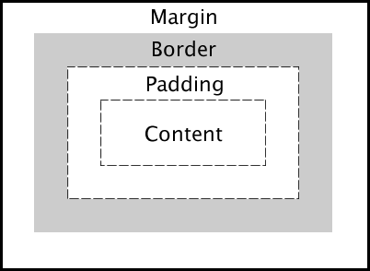

**Below is a brief description of the four procedures that make the CSS box model:**

* **Margin- is transparent, displays the elements, and clears a space between the borders.**
* **Border- are sometimes used with colour or they are used with no colour. They are used to decorate webpages and make them look appealing.**
* **Padding- is the space between the content and the border. Same as the margin the padding is also transparent.**
* **Content- is the element that appears in the box, which could be text numbers or images etc.**

**Example of CSS box model on one of my websites:**

**HTML:**

**<div class="column">**

**<img src="https://cdn.glitch.com/a4312852-36b0-438f-a76d-f53083ae0455%2Fh1.jpg?v=1570568732360">**

**<img src="https://cdn.glitch.com/a4312852-36b0-438f-a76d-f53083ae0455%2Fh2.jpg?v=1570568741647">**

**<img src="https://cdn.glitch.com/a4312852-36b0-438f-a76d-f53083ae0455%2Fh4.jpg?v=1570568750529">**

**<img src="https://cdn.glitch.com/a4312852-36b0-438f-a76d-f53083ae0455%2Fh3.jpg?v=1570568750779">**

**<img src="https://cdn.glitch.com/a4312852-36b0-438f-a76d-f53083ae0455%2Fh5.jpg?v=1570568750836">**

**</div>**

**CSS:**

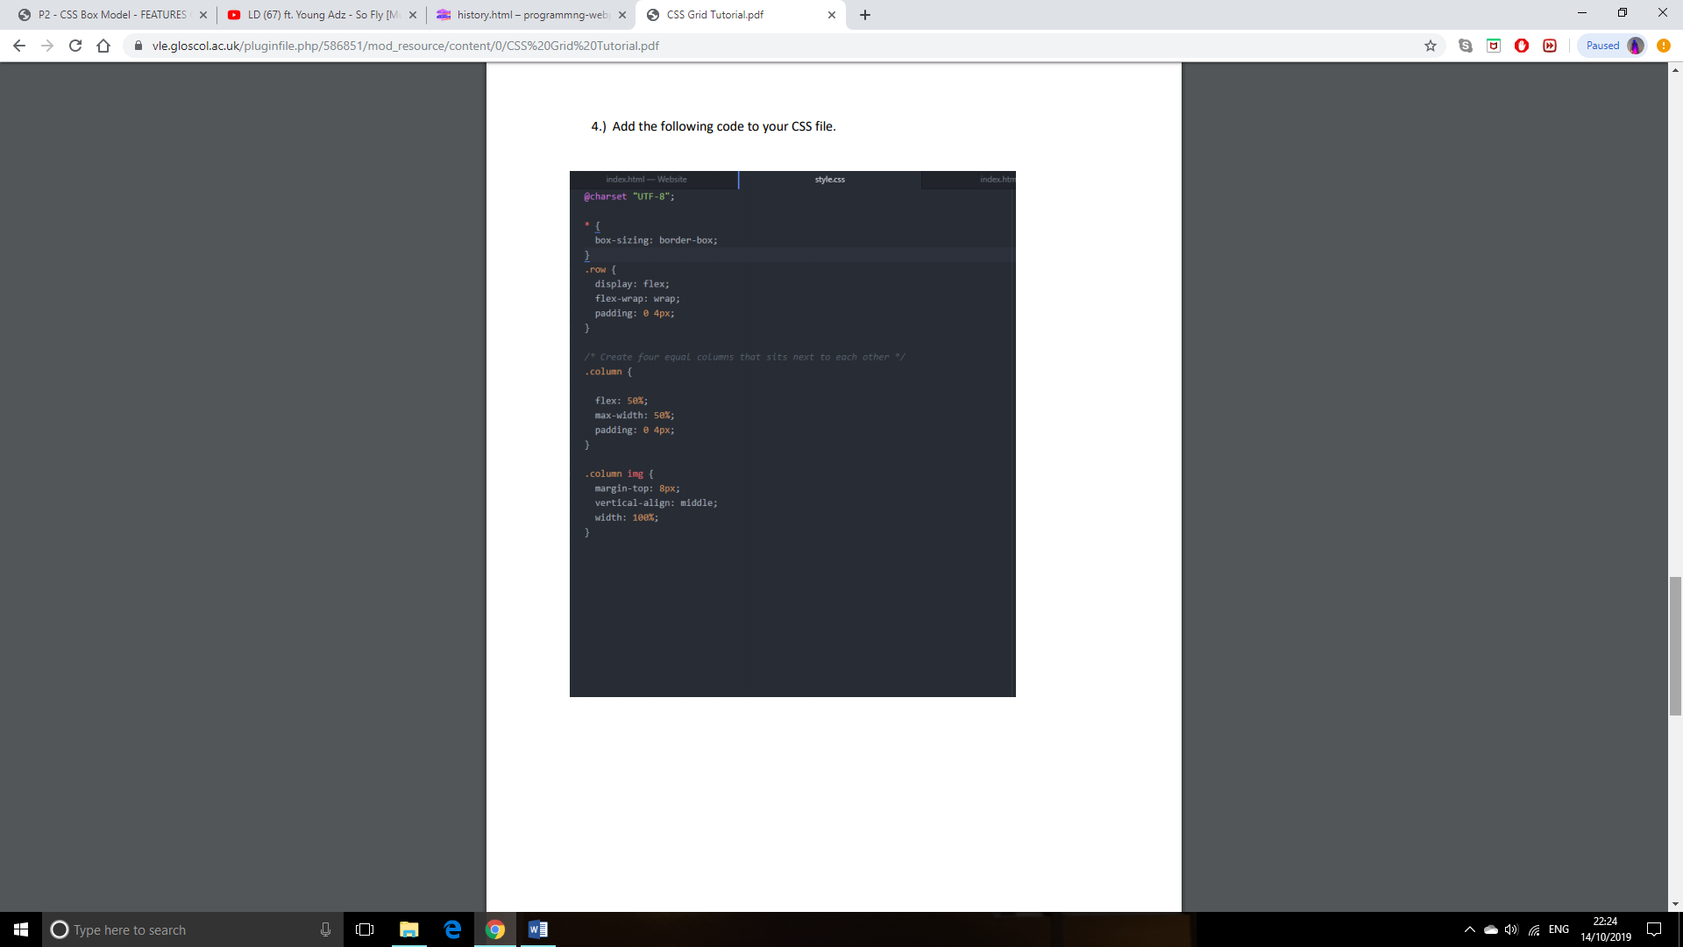

**Final look:**

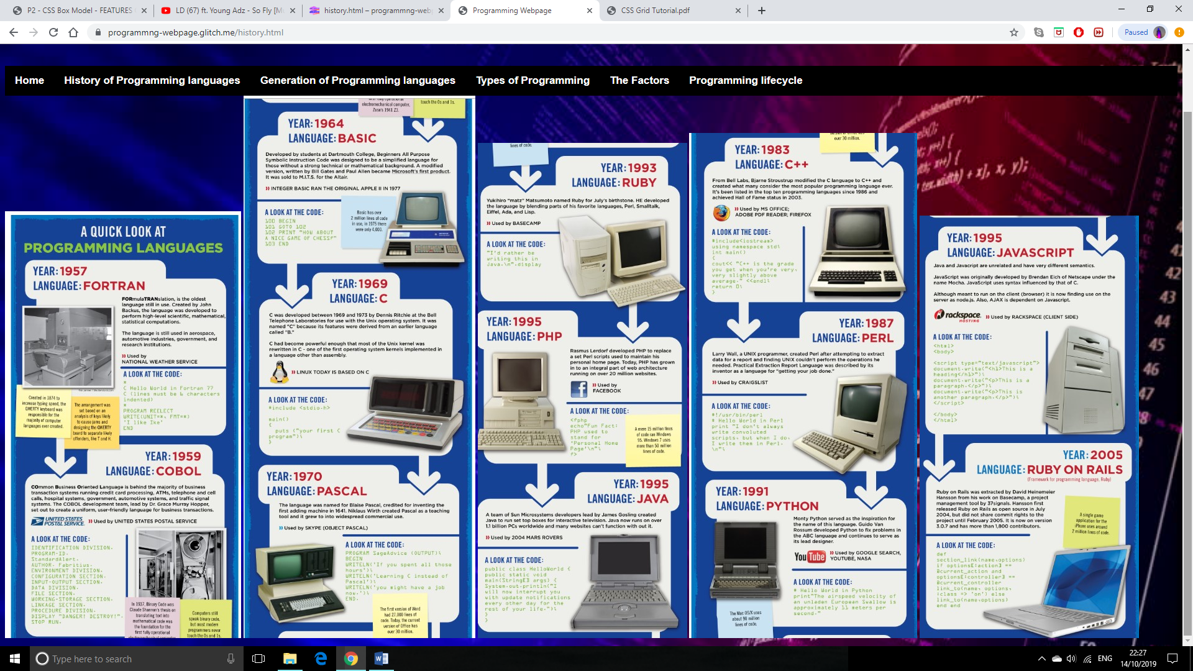

1. Assess the different implementation styles of CSS

**Inline- is when you use the word style after the element that needs to be styled in a HTML document.**

**<!DOCTYPE html>**

**<html>**

**<body>**

**<h1 style="color:blue;text-align:center;">This is a heading</h1>**

**<p style="color:red;">This is a paragraph.</p>**

**</body>**

**</html>**

**Embedded- is where a separate CSS stylesheet is used.**

**<style>**

**body {**

**background-color: linen;**

**}**

**h1 {**

**color: maroon;**

**margin-left: 40px;**

**}**

**</style>**

**External- is where the HTML is linked to the CSS using a link tag where the CSS will link to all the HTML pages.**

**<link rel="stylesheet" type="text/css" href="mystyle.css">**

**Advantages:**

* **If you make a change to the CSS it will affect all the other linked pages**
* **The webpage looks far more consistent on multiple pages**
* **It has a better loading time as the CSS file is installed once and applied to the relevant HTML pages.**

Support your answers with examples.

**Note**: You are advised to research wherever possible and use correctly referenced sources.